Ean Bynoe

[Draw your reader in with an engaging abstract. It is typically a short summary of the document. When you’re ready to add your content, just click here and start typing.]

[Document title]

[Document subtitle]

# Introduction

## Purpose

Within this software requirements specification document, the software product from “Microsoft Teams”, will be used. To be more specific the build version that will be discussed is (Version 24215.1007.3082.1590) of the Software. Further breaking down and defining what this software does, Microsoft Teams is a software that is used for communication and collaboration that allows end-users to chat, video conference, as well as file sharing. It also includes integrated apps to have a seamless interface. This documentation will cover the key requirements for the Desktop (Windows and Apple), web as well as the mobile applications of Microsoft Teams.

## Document Conventions

* Describe any standards or typographical conventions that were followed when writing this SRS, such as fonts or highlighting that have special significance. For example, state whether priorities for higher-level requirements are assumed to be inherited by detailed requirements, or whether every requirement statement is to have its own priority
* **Layout**
  + To ensure consistency and elegant relationships between the design components, “Microsoft Teams” relies on a grid layout
* **Avatars**
  + An avatar is a graphical representation of a person, team, bot, or entity in Teams. An Avatar group I often used to convey live activity or represent a roster in a way that preserves vertical space
* **Type**
  + Teams uses Segoe User Interface for its type ramp and different font sizes and weights to help create hierarchy and ensure readability.
    - Semibold weights were mainly used for the hears and subheaders while Regular weights were used for normal typography.
      * These sizes being:

|  |  |  |  |
| --- | --- | --- | --- |
| **Weight** | **Usage** | **Core Class** | **React Variable** |
| Regular (400) | Size 10-24px | ms-fontWeight-regular | FontWeights.regular |
| Semibold (600) | Size 18-32px | ms-fontWeight-semibold | FontWeights.semibold |
| Bold(700) | Limited usage | ms-fontWeight-bold | FontWeights.bold |

* **Colours:**
  + Teams web and desktop supports default(light), dark, and high-contrast theme, while theme supports light and dark themes. Each theme has its own colour scheme.
    - These being:
      * For the Dark theme – black and #6264A7
      * For the Light theme – white and #6264A7

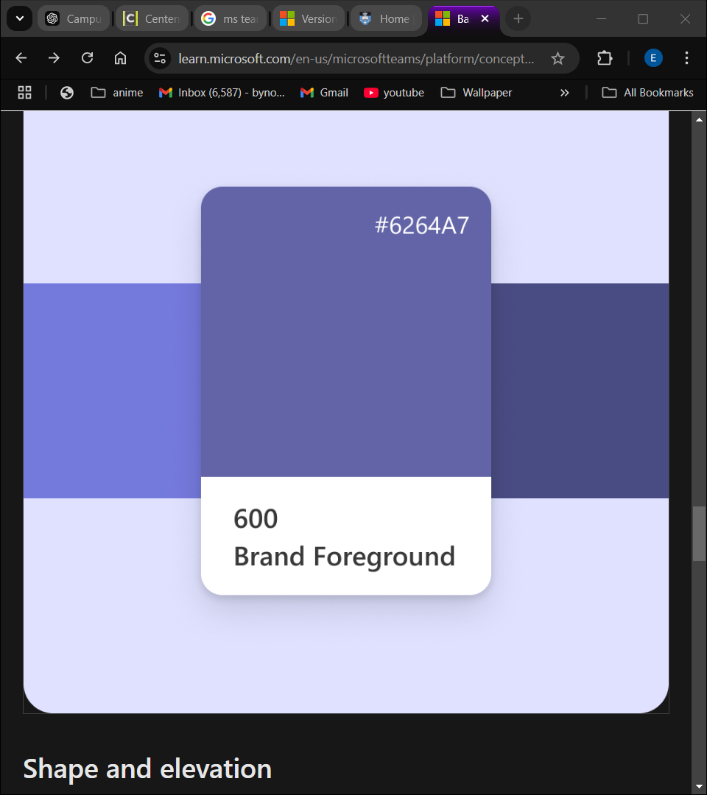

* **Table of Acronyms**

|  |  |
| --- | --- |
| **Acronyms** | **Description** |
| MS | Microsoft Teams |
| UI | User Interface |
| HTML | HyperText Markup Language |
| JS | JavaScript |
| CSS | Cascading Style Sheet |
| API | Application Programming Interface |
| TS | TypeScript |
| FR | Functional Requirements |
| NFR | Non-Functional Requirements |
| QA Engineers | Quality Assurance Engineers |
| UX | User Experience |
| MS | MicroSoft |

## Intended Audience and Reading Suggestions

1. Developers
   1. Use the documentation to understand feature requirements, system behaviours, and dependencies
   2. Focus on Functional Requirements for implementation specifics
2. Product Managers:
   1. References the documentation to align product strategies and roadmaps with user needs and system capabilities
   2. Review Overall Description and Non-Functional Requirements to understand system performance goals
3. Test/QA Engineers:
   1. Use the documentation to design test cases and ensure the system meets functional and non-functional requirements
4. IT Administrators:
   1. Deploy and manage the application within organizations
5. UI/UX Designers:
   1. Use the documentation to ensure the design aligns with the functional and accessibility requirements
   2. Focus on User Interfaces and Accessibility Requirements
6. Customer Support Teams:
   1. Refer to documentation to troubleshoot user issues and provide accurate resolutions
   2. Review Product Features and External Interfaces for common and non-common queries and configurations
7. Stakeholders and Executives:
   1. Use this document to gain an overview of the system’s purpose, scope and functionality
   2. Focus on Introduction and Overall Description for strategic insights

# Overall Description

## Product Perspective

* Microsoft Teams is an entirely new service, built for the cloud from the ground up by leveraging Azure and other service innovations from Microsoft.
* Microsoft Teams is built on Microsoft 365 groups, Microsoft Graph, and with the same enterprise-level security, compliance, and manageability as the rest of Office 365. Teams leverage identities stored in Microsoft Entra ID. These services are delivered from Microsoft data centers and are accessible to users on a wide range of devices from inside a corporate network or over the Internet. For more information, see the Microsoft Teams IT architecture and telephony solutions posters.

## Product Features

* Audio conferencing
* Create channels
* Chat (send messages)
* Create Live events
* Schedule Meetings
* Screen sharing PowerPoint/Audio/Video Desktop
* Create Teams
* Voice activities
* Loop Integrations
* Access Microsoft Products
* Collaborate in Real Time
* Integrate Third-Party Applications
* Meeting Recaps

## User classes and Characteristics

* Students:
  + Students will be using the software with the intension of conducting educational activities, with their schools and authorized faculties.
* Small Business:
  + Small Businesses will be using the software for collaborations and communication for projects and day to day essentials.
* Large Businesses:
  + Larger Businesses will be conducting the same uses as a small business but on a much larger scale compared to the smaller business.
* IT Administrators:
  + IT Administrators will manage user accounts and enforce policies and application integrations.
* Developers:
  + Build and integrate custom applications using Teams APIs

## Operating Environment

Microsoft Team will operate on many different platforms. These being:

* + Windows:
    - Computer Processor:
      * Minimum 1.1GHz or faster
    - Memory:
      * 4.0GB Ram
    - Hard disk:
      * 3.0GB of available disk space
    - Display:
      * 1024 x 768 screen resolution or higher
    - Graphics hardware:
      * DirectX 9 or later
    - Operating System:
      * Windows 11, Windows 10(excluding Windows 10 LSTC for Teams desktop app), Windows 8.1, Windows Server 2019/2016 and2012 R2.
    - .Net version:
      * Requires .Net 4.5 CLR or later
    - Video:
      * USB 2.0 video camera
    - Devices:
      * Standard Laptop camera, microphone, and speakers
  + Mac:
    - Computer Processor:
      * Intel Core Duo processor
    - Memory:
      * 4.0GB Ram
    - Hard disk:
      * 1.5GB of available disk space
    - Display:
      * 1280 x 800 screen resolution or higher
    - Operating System:
      * One of the three most recent versions of macOS
    - Video:
      * Compatible webcam
    - Voice:
      * Compatible microphone and speakers, headset with microphone or equivalent device
  + Android:
    - Compatible with Android phones and tablets.
    - Support is limited to the last four major versions of Android. For example, when a new, major version of Android is released, the Android requirement is the new version and the three most recent versions that precede it.
  + iOS:
    - Compatible with iPhone, iPad, and iPod touch.
    - Support is limited to the two most recent major versions of iOS. For example, when a new, major version of iOS is released, the iOS requirement is the new version and the most recent versions that preceded it. The optional Blur my background video effect on iOS requires an operating system of iOS 12 or later, compatible with the following devices: iPhone 7 or later, iPad 2018 (6th generation) or later, and the iPod touch 2019 (7th generation).

## Assumptions and Dependencies

These are the following Assumptions and dependencies for Microsoft Teams:

* Microsoft 365 or Office 365
* A verified domain for Microsoft 365 or Office 365
* Synchronized identities to Microsoft Entra ID
* Have Exchange Online
* Have SharePoint Online
* Network Requirements have been met.

# External Interface Requirements

## User Interfaces

## Hardware Interfaces

## Software Interfaces

## Communications Interfaces

References:

**Naming Conventions:** <https://uct.ac.za/research-support-hub/research-data-managing-research-data/file-naming-conventions-ms-teams>

**Microsoft Teams app design system:** <https://learn.microsoft.com/en-us/microsoftteams/platform/concepts/design/design-teams-app-fundamentals>

**Scope Audience size and determine audience preferences:** <https://learn.microsoft.com/en-us/sharepoint/audience-profile>

**Microsoft Teams service description:** <https://learn.microsoft.com/en-us/office365/servicedescriptions/teams-service-description>

**Microsoft Teams 40 Features:** <https://www.stanfieldit.com/microsoft-teams/>

**Microsoft Teams Hardware Requirements**: <https://learn.microsoft.com/en-us/microsoftteams/hardware-requirements-for-the-teams-app>

**Prerequisites and environmental dependencies for Teams:** <https://learn.microsoft.com/en-us/microsoftteams/upgrade-plan-journey-prerequisites>